PLICKER CARDS DATABASE FOR DBMS QUIZ

p.sneha anjali

**ABSTRACT**

Plickers is a free, interactive tech tool that uses printable “paper clickers” of clicker devices. Each student is assigned a unique Plickers card that has a black and white image similar to a QR code. The letters A, B, C, and D are written in small print around the edge of the image, with one letter on each side of the card. During the lesson, the teacher displays a multiple-choice or true-false question. Then students hold up their Plickers cards and rotate them to indicate which answer they think is correct. The teacher scans all of the response cards at once, using the Plickers app installed on a mobile device. He or she can instantly see the student responses and assessment data for that question including who has the correct answer and who does not.

Teacher assigns a plicker card to each student and the student have to give the correct option or the question. The teacher scans the assigned plicker and displays the result. By using this method the results can be generated fastly.

**ER DIAGRAM**

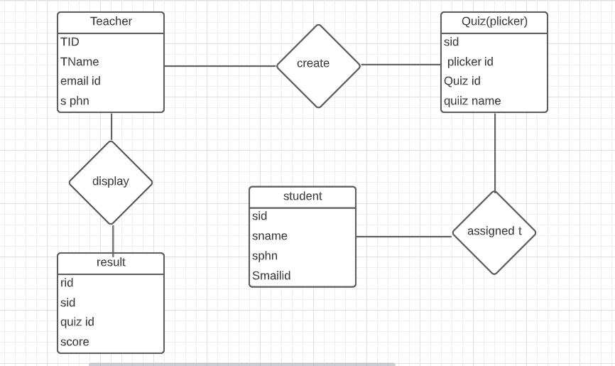

DDL OPERATIONS

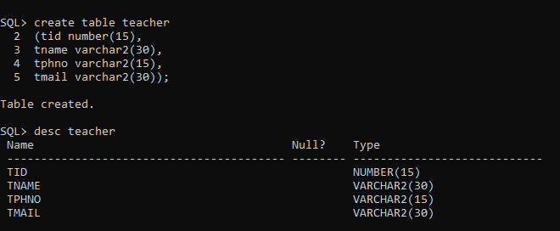

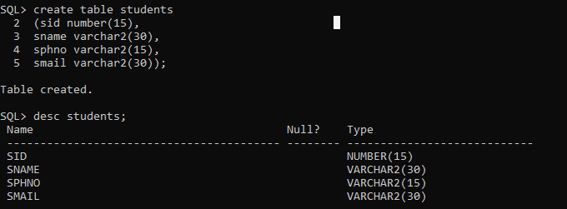

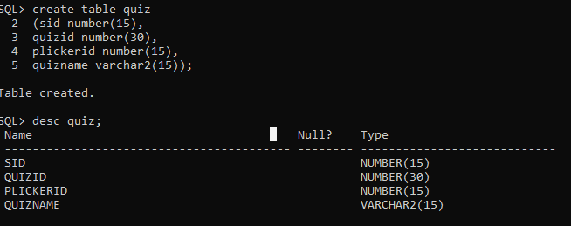

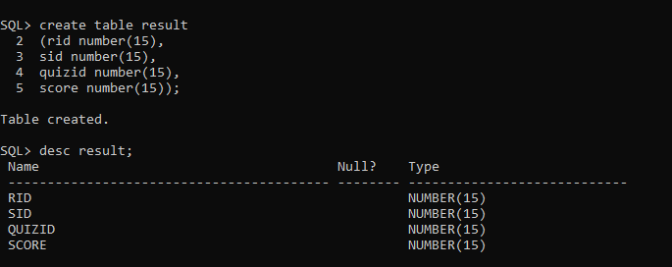

ENFORCING CONSTRAINTS

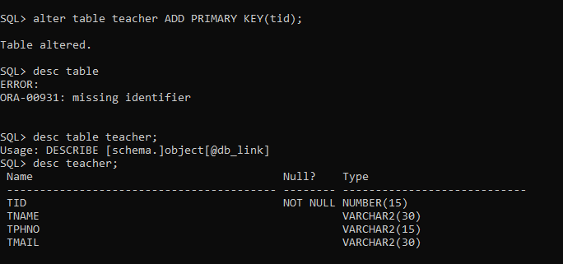

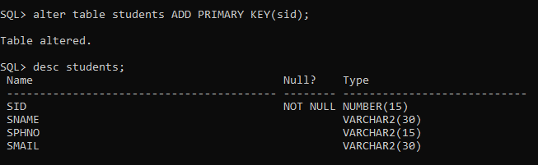

dbms 1 a.PNG

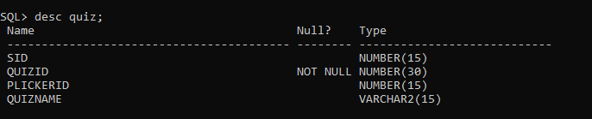

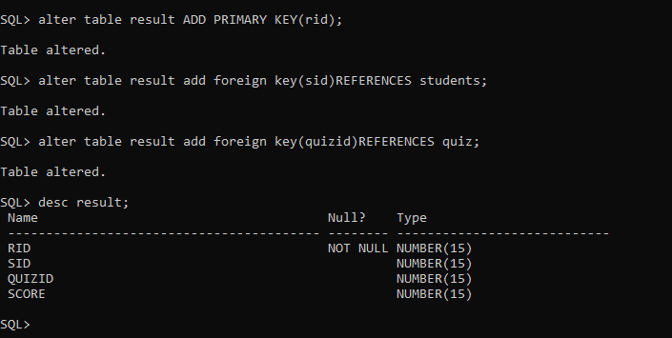

**DML OPERATIONS**

